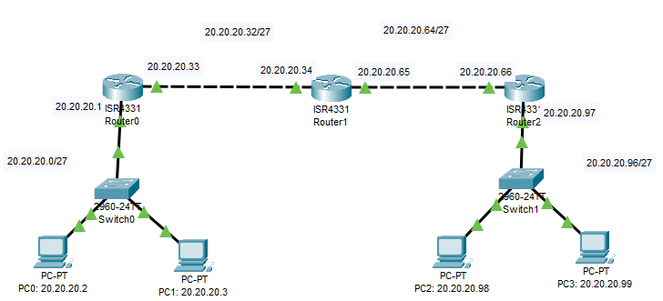
Fig: Topology of The Network

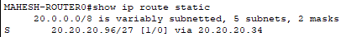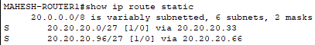

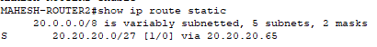 Table: static route table of each router

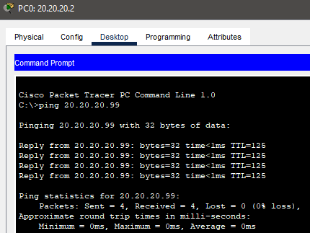
Fig: ping command to test connection between PC0 to PC3

